Name: ICT Assessment: 5E-5M Tutor Group:
MY ICT | DIGITAL LITERACY  Understanding of how to use technology safely and responsibly. | COMPUTER SCIENCE  Ability to design write and debug programs; knowledge of sequencing and logical reasoning. | INFORMATION TECHNOLOGY  Ability to demonstrate basic IT skills and use of software to explore, present ideas and solve problems. | CHARACTER  Personal, social and interactive beahvour within lessons.  Holistic development.
Secure/  Mastered | I can confidently list and explain the dangers when using the internet and technology.  I can list the SMART e-safety rules and explain all of them in detail with examples. | I can name all the script groups and have a good knowledge of what the blocks of codes in the group can be used for when writing code.  I can use sequencing to write more advanced code in code that allows for more complex ations such as user defined movement/writing basic a basic game. | I can confidently use the advanced tools and a variety of functions on both Word and Publisher to create a document fit for purpose.  I can confidently navigate between the student view and my documents and save my work within correct folders | I can respect and listen to peers feedback and contributions and consistently show a positive attitude within lessons.  I can collaborate with others and volunteer to show final product/work.
Developing | I can list 4 or more dangers of the internet and technology.  I can name 5 E-safety SMART rules and define at least three of them. | I can name 4 or more script groups and explain what the blocks within the group can used for when writing code.  I can use sequencing to write code to achieve more complex actions (e.g. getting a sprite to draw, change costumes, or move in many directions). | I can independently use a variety of the basic tools and functions on both Word and Publisher to create an appropriate document.  I can access the student view and my documents areas on the network and can save my work. | I can listen and respond to teachers instructions and questions. I can also answer questions when asked and often shows a positive attitude.  I can often cooperate and communicates with different students effectively.
Emerging | I can list at least 2 dangers of the internet.  I can list 3 SMART e-safety rules. | I can define the terms ‘sprite’, ‘backdrop’’ & name and at least two script groups.  I can use sequencing to write simple code within Scratch to achieve a simple action (e.g. move ten steps). | I can choose an appropriate template on either Word or Publisher and I am beginning to explore using a few tools such as font size and style to create a document.  I can understand the difference between ‘student view’ and my own documents and how to create folders. | I can follow rules and expectations throughout the lesson, be punctual and I usually demonstrate a postitive attitude.  I can sometimes work effectively with others.

REFLECTION:
Winter |  | Spring |  | Summer
Digital Literacy | /6 | Digital Literacy | /6 | Digital Literacy | /6
Computer Science | /6 | Computer Science | /6 | Computer Science | /6
Information Technology | /6 | Information Technology | /6 | Information Technology | /6
Character | /6 | Character | /6 | Character | /6
Total | / 24 | Total | / 24 | Total | / 24
My Strength: _______________  ____________________________________________________________________________________________________________  My target: _________________  ____________________________________________________________________________________________________________  I am proud of myself because:  __________________________  ____________________________________________________________________________________________________________ |  | I have improved by _____ points  My Strength: _______________  ____________________________________________________________________________________________________________  My target: _________________  ____________________________________________________________________________________________________________  I am proud of myself because:  __________________________  ____________________________________________________________________________________________________________ |  | I have improved by _____ points  My Strength: _______________  ____________________________________________________________________________________________________________________  My target: _________________  ____________________________________________________________________________________________________________________  I am proud of myself because:  __________________________  ___________________________________________________________________________________________________________________

Superhero skills used in winter term  Creative thinker  Reflective learner  Self-manager  Effective participator  Independent enquirer  Team worker | Superhero skills used in Spring term  Creative thinker  Reflective learner  Self-manager  Effective participator  Independent enquirer  Team worker | Superhero skills used in summer term  Creative thinker  Reflective learner  Self-manager  Effective participator  Independent enquirer  Team worker
What fruits of faith have you used:  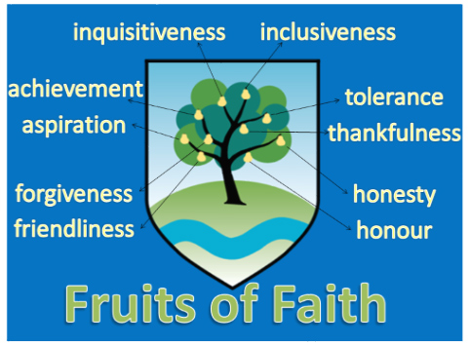 | What fruits of faith have you used: | What fruits of faith have you used:
E = 0-6 D = 7-13 S = 14-19 M = 20-24

